AP Calc AB Name: _______________

______________ _____________

WS Assessment

Target 16:

Fundamental theorem of calculus

**I can:**

* Calculate a definite integral using areas and properties of definite integral.
* Evaluate definite integrals analytically using the FTC
* Determine antiderivatives of functions and indefinite integrals, using knowledge of derivatives

Unit 6: Integration and Accumulation of Change

HW Target 16 Unit 6 Progress Check FRQ A and B



Write $\int_{1}^{3}{f\left(x\right)dx}$ as the limit of a Riemann sum with f(x) = x3

We have the model $\lim_{n→∞}{\sum_{k=1}^{n}{f(a+k∆x)∆x}}$ to use. We know that a = 1; $∆x=\frac{b-a}{n}=\frac{2}{n}$ so

$$\lim_{n→∞}{\sum_{k=1}^{n}{f\left(1+k\frac{2}{n}\right)\frac{2}{n}=\lim_{n→∞}\sum_{k=1}^{n}{f\left(1+\frac{2k}{n}\right)\frac{2}{n}}}}$$

Since f(x) = x3, our Riemann sum becomes

$$\lim_{n→∞}\sum_{k=1}^{n}{{\left(1+\frac{2k}{n}\right)}^{3}\frac{2}{n}}$$

Check with your calculator for n = 100

Rewrite the following as the limit of a Riemann sum with the given f(x), then find its values. Show me both in calculator for stamp

|  |  |  |  |
| --- | --- | --- | --- |
| Function | Integral | Limit of Riemann sum | Value |
| f(x) = x4 |  |  |  |
| f(x) = 3x2 |  |  |  |
| f(x) = x4 |  |  |  |
| f(x) = sin(4x2) |  |  |  |
|  | |  |  |

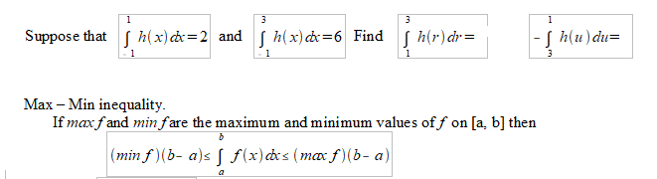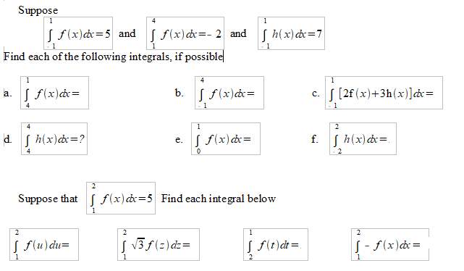Properties of define integral

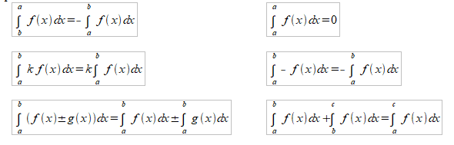Show that $\int_{0}^{1}{\sqrt{1+cos⁡(x)}dx} <\frac{3}{2}$

Average Value of Function

If *f* is integrat-able on [a, b], its average (mean) value on [a, b] is

$$Avg f=\frac{1}{b-a}\int_{a}^{b}{f\left(x\right)dx}$$

Find the average value of the following

f(x) = 4 – x2 on [0, 3] f(x) = x2 – 1 on [0, 3.5]

f(x) = -3x2 – 1 on [0, 1] f(x) = (x – 1)2 on [0, 3]

Mean Value Theorem for Definite Integral

If f is continuous on [a, b], then at some point c in [a, b] $f(c)=\frac{1}{b-a}\int_{a}^{b}{f\left(x\right)dx}$

Determine the number c that satisfies the Mean Value Theorem for Integrals for the function

f(x) = x2 + 3x + 2 on the interval [1,4]

Fundamental Theorem of Calculus 1 and 2. Watch video

|  |  |
| --- | --- |
| $$\frac{d}{dx}\left(\int_{a}^{x}{f\left(t\right)dt}\right)=f(x)$$ | $$\int_{a}^{b}{f\left(x\right)dx}=F\left(b\right)-F(a)$$ Where F is anti-derivative of *f* |

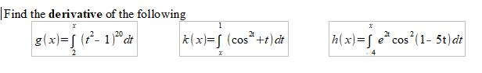

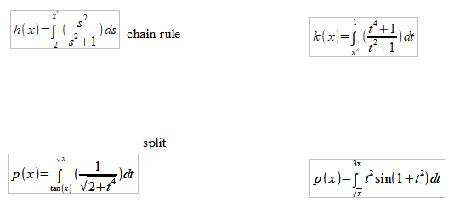

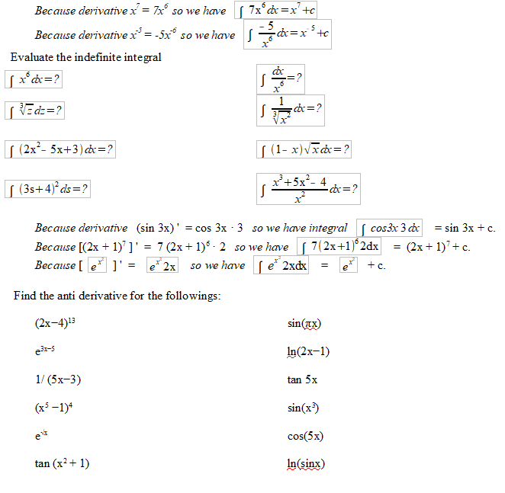

**Assessment Target 16**

Rewrite $\int_{2}^{7}{\sqrt{x+1}dx}$ as the limit of a Riemann sum then find its values.

Find f avg for f(x)=4x2 – x + 5 on [−2,3] and determine the value(s) of c in [−2,3] for which

f(c) = f avg

Suppose that the velocity function of a particle moving along a coordinate line is v(t) = 3t3 + 2. Find the average velocity of the particle over the time interval [1, 4]

Suppose that the position function of a particle moving along a coordinate line is s(t) = 6t2 + t. Find the average velocity of the particle over the time interval [1, 4]





